**Example 1**

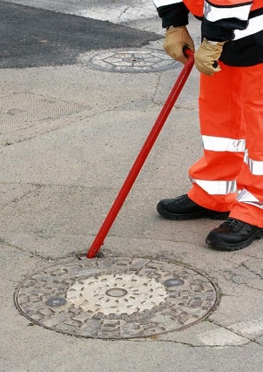Lever is used to lift manhole cover. The mass of a manhole cover is 113 kg, which is

much more than a typical worker can lift without any outside help. Even a

body builder might have a hard time lifting a manhole cover from the ground.

By using a lever, the worker is able to significantly increase their strength and lift

the manhole cover.

How much strength does the worker need to put into lifting the manhole? Let’s assume that the worker is using a 1 m lever and inserts 10 cm into the manhole opening, then the weight necessary to lift the manhole cover is calculated like this:

Ration = 90 / 10 = 9

Weight = 113 / 9 = 12.5

In order to lift the manhole cover of 113 kg, the worker should use 12.5 kg of weight on the longer side of the lever. Lever is designed to increase force.

**Example 1**

Pulleys are used to lift weight. In the reading, it was described how the number of wheels effects the mechanical advantage. 1 wheel gives 1 mechanical advantage, 2 wheels give 2 mechanical advantage, 3 wheels give 3 mechanical advantage, and so forth. However, the tradeoff is rope length and time. Greater weight can be lifted by adding more wheels, but the length of the rope and time to pull the rope will increase accordingly.

**Example 3**

Screws are the most commonly used devices in the world. Thy convert rotation motion into linear motion. Screws are designed to increase force. The most common application for screws is to connect 2 or more pieces of something together, for example to connect table legs to the table. In order to penetrate the hardwood of the table, the worker only needs to use a screwdriver to complete the task. By contrast, a nail is also used to connect 2 or more pieces together; however, to complete the task, the worker needs to use another simple machine called hammer in order to gain necessary mechanical advantage to put the nail into place.